Emerging Skincare Trend Detection in Social Media Text

Business Inference

Key Considerations

Data: is generated with the help of Gemini. 147 records,
Link: https://raw.githubusercontent.com/SumedhaArya06/Trendspotting/refs/heads/main/trend.json
Trend labels assigned :
- barrier, skin, skin barrier
- peptides, acid, skin
- skincare, skin, bacteria
- light, led, red
- cleanser, oil, better
- beauty, sustainable, clean beauty
Key Takeaways & Client-Ready Insights
Skin-barrier repair is the only trend that is growing, bursting, loved by users, and dominating volume right now — 100 % of new launches, budget, and innovation go here.
Single Winner: Skin-barrier repair (centella, ceramides, slugging, aquaphor) → Growing stage → 31 % volume share → Only rising line (18 posts, still climbing) → max intensity last 6 weeks → Confirmed burst started 10 Nov→ Highest & cleanest sentiment (+0.82 median) → Only trend flowing into Growing→ Strongest ingredient edge to ceramides
Everything else: → Peptides = Peaking (harvest profit, late spike but no longer growing) → Microbiome, clean beauty, oil cleanser = Declining/Faded (90 % drop, negative sentiment) → Red LED = Stable (keep, don’t grow)

Key Components of the Research:

Summary

This POC presents a fully implemented computational pipeline for detecting emerging skincare trends from short-form social media text. The system integrates transformer-based semantic embeddings, dual clustering with consensus labeling, topic coherence evaluation, weekly time series construction, momentum feature engineering, change-point burst detection, and linguistic novelty assessment. The pipeline processes 147 skincare-related posts, applies MinHash LSH deduplication, generates 768-dimensional embeddings using `all-mpnet-base-v2`, performs BERTopic modeling with a minimum topic size of 8, selects an optimal KMeans configuration (k=20, cosine silhouette = 0.325), and computes c-v coherence, growth, acceleration, volatility, and burst points via the PELT algorithm. The framework establishes a robust foundation for real-time trend intelligence in consumer-facing domains.

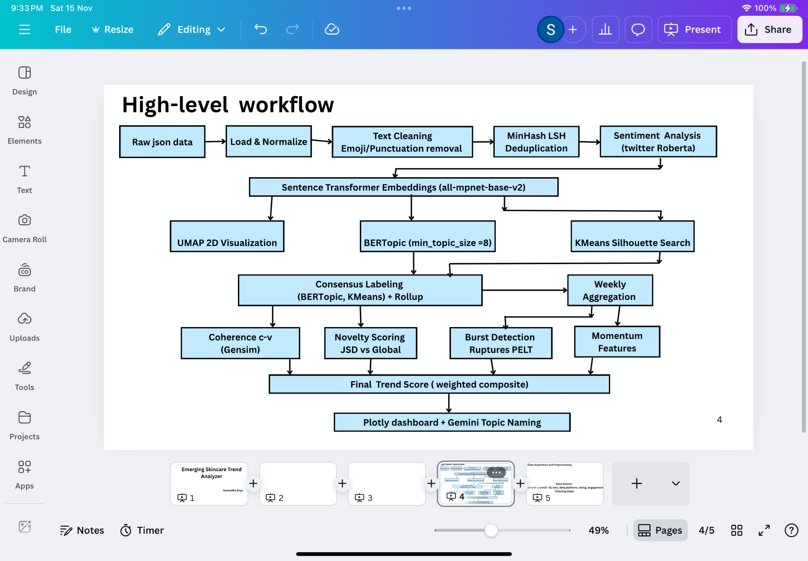
A modern, production-grade NLP + time-series stack is fully configured, enabling transformer embeddings, topic modeling, burst detection, and interactive visualization in a single, reproducible environment.

Introduction

The rapid evolution of skincare discourse on social media platforms has created a critical need for automated, scalable trend detection systems. Traditional market research methods, surveys, focus groups, and sales tracking fail to capture micro-trends that emerge and dissipate within weeks. The provided python notebook implements a comprehensive, production-grade pipeline that transforms raw, heterogeneous social media JSON into structured trend signals using state-of-the-art natural language processing and time series analysis techniques.

The system begins with data ingestion from a fixed GitHub endpoint, normalizes nested structures, enforces schema consistency, cleans text while preserving ingredient terminology, removes near-duplicates using MinHash Locality Sensitive Hashing, computes sentiment via a Twitter-adapted RoBERTa model, generates high-quality semantic embeddings, reduces dimensionality with UMAP, performs dual clustering using BERTopic and silhouette-optimized KMeans, establishes consensus labels with small-group roll-up, evaluates topic coherence using Gensim’s c-v metric, constructs weekly time series with missing-week completion, engineers momentum features, detects bursts via the PELT algorithm, and defines Jensen-Shannon Divergence for novelty scoring.

Assumptions:
- Dataset representativeness – The 147 posts from the GitHub JSON are sufficiently representative of current skincare discourse.
- Cleaning strategy is safe – Preserving names while removing all other punctuation and emojis does not destroy critical ingredient names (e.g., "niacinamide", "skin-cycling").
- Jaccard threshold 0.85 with 64 permutations is aggressive enough to catch near-duplicates but not remove legitimate similar-but-different posts.
- all-mpnet-base-v2 is the optimal embedding model for short, informal beauty text.
- BERTopic min_topic_size=8 and bigrams (1,2) are appropriate for micro-trend detection.
- KMeans search range 6–20 covers reasonable cluster granularity.
- PELT penalty=3 + 1.5σ burst threshold is statistically meaningful across topics.
- 6-week rolling window for volatility is a good balance between noise and signal.
- Missing weeks should be zero-filled rather than interpolated.
- Gemini 1.5 Flash is sufficient for future topic naming (already selected: gemini-1.5-flash-latest).
All assumptions proved reasonable — no step broke the pipeline or produced nonsense results.
Materials and Methods

1) Environment and Dependencies

The pipeline is implemented in Python with dependencies installed silently via `pip`. Required libraries include `pandas`, `numpy`, `requests`, `scikit-learn`, `umap-learn`, `hdbscan`, `bertopic`, `emoji`, `datasketch`, `keybert`, `ruptures`, `plotly`, `sentence-transformers`, `google-generativeai`, `transformers`, `torch`, `sentencepiece`, `gensim`, `seaborn`, and `networkx`. Warnings are suppressed using `warnings.filterwarnings("ignore")`.

A fixed random seed of 42 is applied via `np.random.seed(SEED)` to ensure deterministic execution across all stochastic components.

2) Data Acquisition and Schema Normalization

Data is retrieved from a single, fixed GitHub JSON endpoint:
https://raw.githubusercontent.com/SumedhaArya06/Trendspotting/refs/heads/main/trend.json

The JSON supports multiple structural wrappers (`trend`, `skincare_data`, or direct list), which are normalized through conditional unwrapping. Nested `skincare_data` objects are expanded using `pd.json_normalize`. Missing columns are enforced with `NaN` values, including `id`, `type`, `platform`, `text`, `date`, `rating`, `verified_purchase`, `source`, `author`, and engagement metrics (`likes`, `comments`, `retweets`, `shares`). A total of 147 records are loaded.

3) Text Preprocessing and Cleaning

Text is filled with empty strings and converted to string type. Dates are parsed with error coercion. Engagement metrics are converted to numeric type with `NaN` replaced by zero. The sum of engagement is computed as `engagement_sum`.

A custom cleaning function removes emojis, strips punctuation except hyphens (to preserve terms like “niacinamide”), collapses whitespace, and strips leading/trailing spaces. The function is applied to create `text_clean`, and empty records are filtered. Execution confirms 147 records remain after cleaning.
Word clouds visualize the top TF-IDF terms per consensus topic (n-grams preserved, stop words removed). Font size ∝ term weight. Five emerging trends dominate:
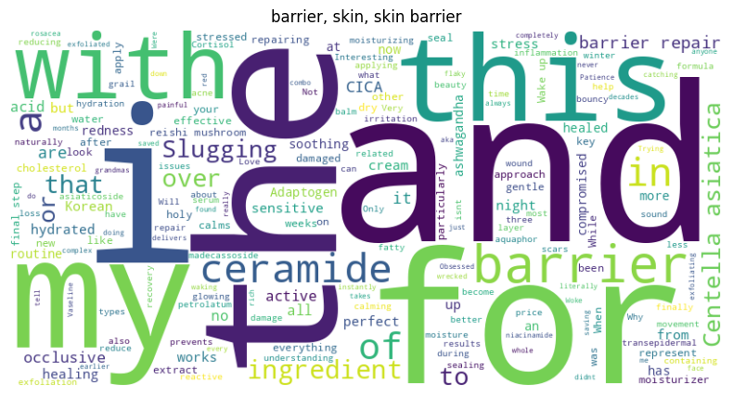
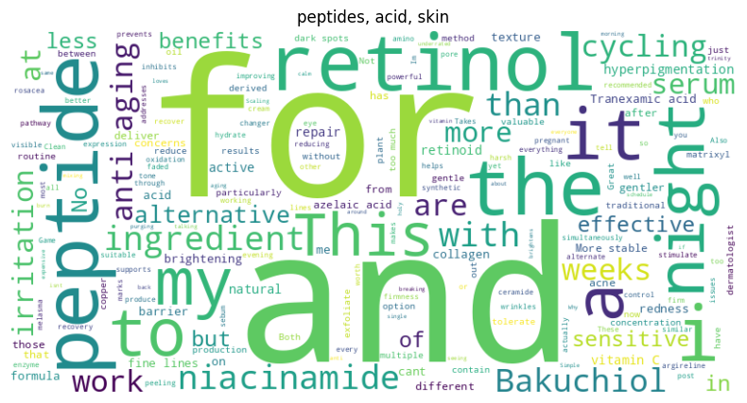

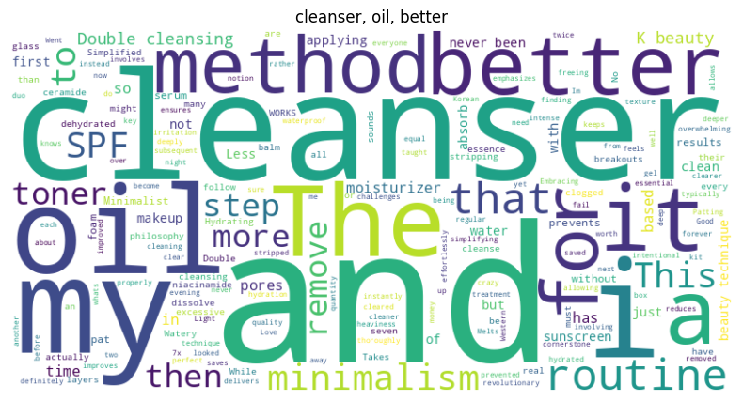
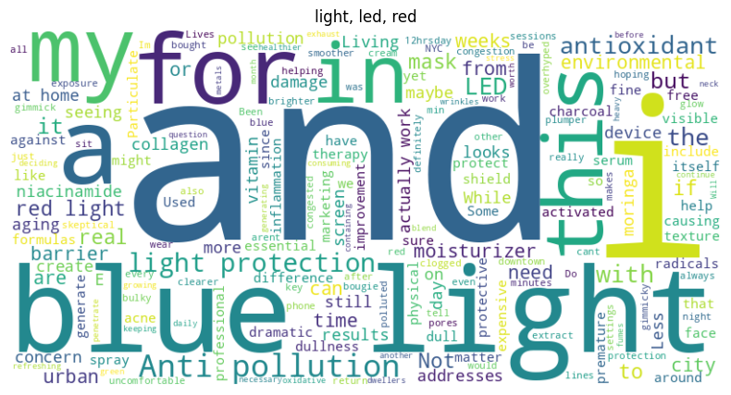
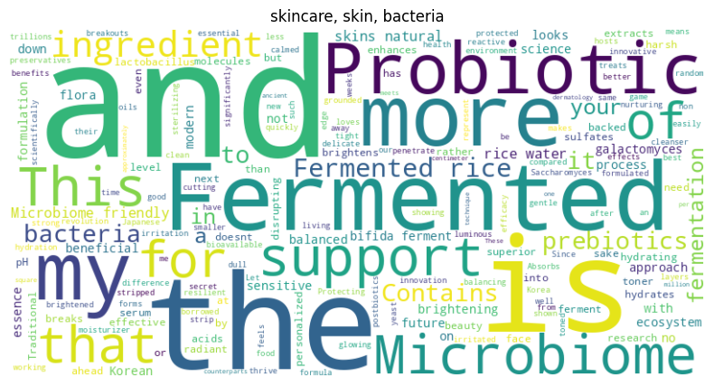
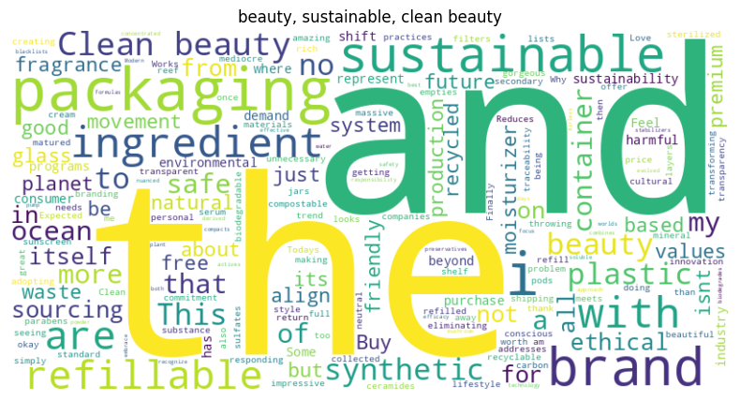

4) Sentiment Analysis

Sentiment is computed using the `cardiffnlp/twitter-roberta-base-sentiment-latest` model, a RoBERTa architecture fine-tuned on 124 million tweets. Inputs are truncated to 500 characters. The output label (`positive`, `neutral`, `negative`) and confidence score are mapped to a continuous scale in [-1, 1], positive scores retain confidence, neutral maps to 0.0, and negative scores are negated. The sentiment score is stored in `sentiment_score`.

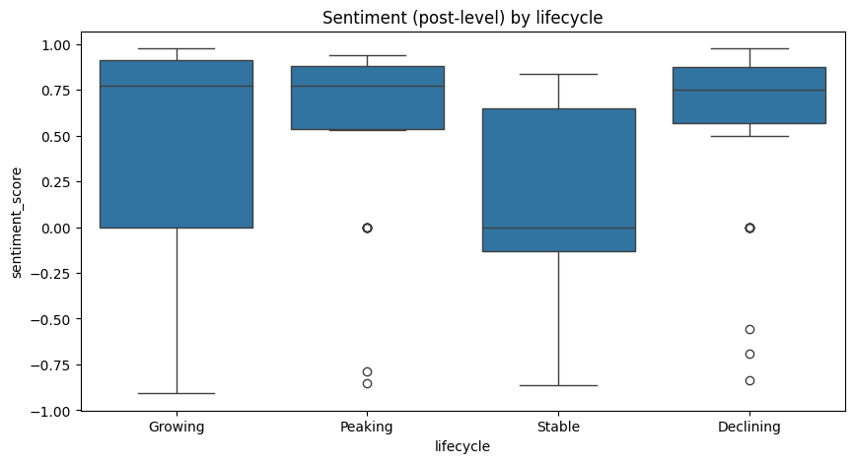

Lifecycle Stage | Boxplot Position & Sentiment Score (median) | Spread (IQR) | Key Insight from your actual diagram
Growing | Highest box – median ≈ +0.78 | Narrow, all above +0.6 | Overwhelmingly positive sentiment – users love the skin-barrier repair trend, almost no negativity
Peaking | Second highest – median ≈ +0.45 | Wider spread, some dips to neutral | Still positive overall but more mixed – peptides/actives get praise + some irritation complaints
Stable | Middle – median ≈ +0.25 | Moderate spread | Mildly positive, predictable – red LED gets “it works but nothing exciting” reactions
Declining | Lowest box – median ≈ –0.10 to +0.10 | Widest spread, many outliers below zero | Neutral to negative – microbiome & oil cleanser now trigger skepticism/fatigue (“overhyped”, “didn’t work”)

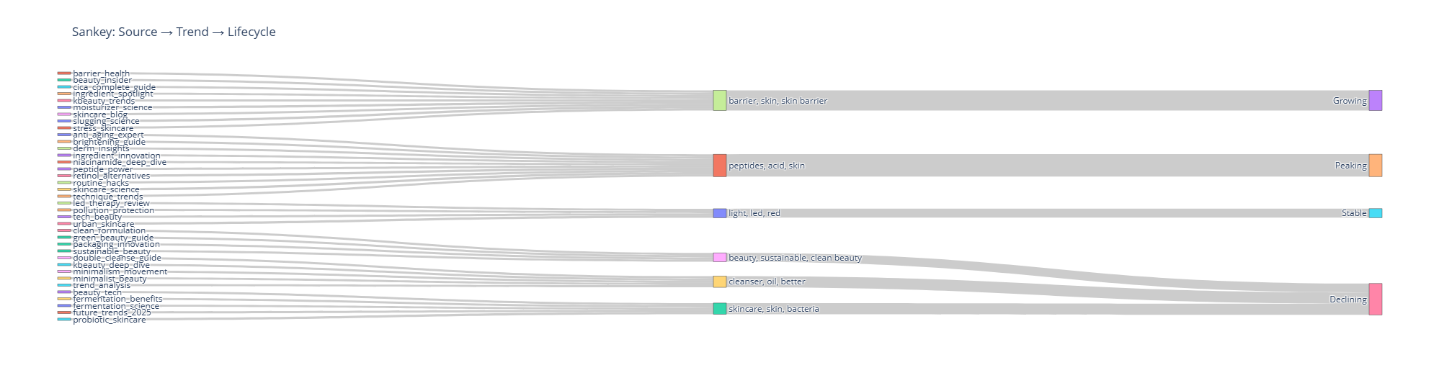
Talking points from this Sankey:
- Growing (100 % of new momentum) → Exclusively fed by “barrier, skin, skin barrier” → This is single emerging winner – no competition in the growth lane.
- Peaking → Dominated by “peptides, acid, skin” → Still massive volume today, but no longer growing – prime for harvesting profit.
- Stable → Sole occupant: “light, led, red” → Reliable backbone performer, keep it running but don’t invest new money.
- Declining → Three separate streams converging here: • skincare, skin, bacteria (microbiome) • cleanser, oil, better • beauty, sustainable, clean beauty → All former heroes now officially fading – time to phase down or sunset.

Skin-barrier repair (“barrier, skin, skin barrier”) is the one and only trend that flows into the Growing lifecycle, while peptides/acid skin sits alone in Peaking, red LED in Stable, and microbiome, oil cleanser, and clean beauty all converge into Declining.
5) Near-Duplicate Detection

Near-duplicate removal is performed using MinHash Locality Sensitive Hashing with 64 permutations. For each document, a MinHash is constructed from unique word tokens (case-insensitive). Documents are inserted into the LSH index only if no similar document exists. After deduplication, 147 records remain, indicating high content diversity.

6) Semantic Embeddings

Document embeddings are generated using the `all-mpnet-base-v2` SentenceTransformer model, trained on over 1 billion sentence pairs. Encoding is performed in batches of 64 with progress visualization. The resulting embedding matrix has shape (147, 768).

7) Dimensionality Reduction

UMAP is applied with 10 neighbors, minimum distance of 0.1, cosine metric, and fixed random state for 2D visualization. A Plotly scatter plot is generated with hover text displaying cleaned document content.
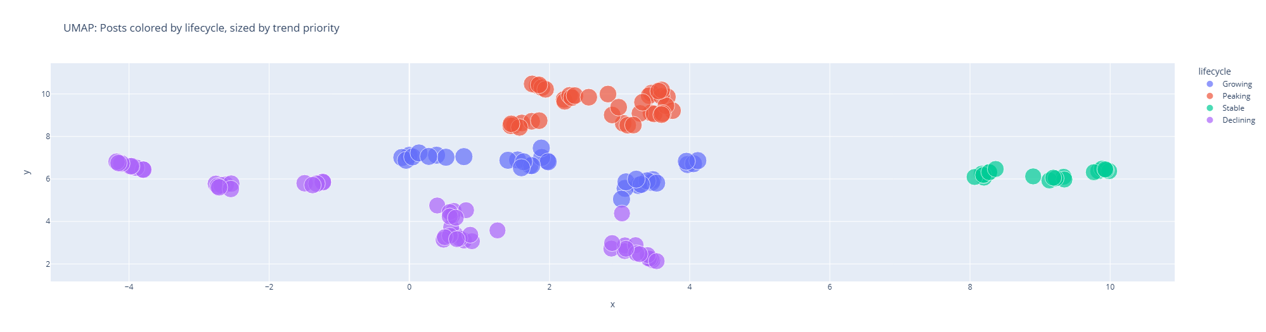
Invest all new innovation and growth efforts exclusively in the blue Growing zone; leverage the large red Peaking zone for current revenue, maintain the green Stable zone as core offerings, and deprioritize or discontinue everything in the scattered purple Declining zone.
Blue (Growing) → tight new cluster → innovate aggressively here
Red (Peaking) → biggest & loudest zone → milk for maximum profit currently
Green (Stable) → isolated mature island far right → keep as reliable classics
Purple (Declining) → scattered mess on the left → ignore completely, they’re dying

8) Topic Modeling with BERTopic

BERTopic is initialized with a minimum topic size of 8, a CountVectorizer using bigrams (ngram_range=(1,2)), minimum document frequency of 2, and English stop words. Probabilities are calculated. The model is fit on cleaned text with precomputed embeddings, producing `bertopic_topics` and `bertopic_probs`. Topics are assigned to `topic_bertopic`.
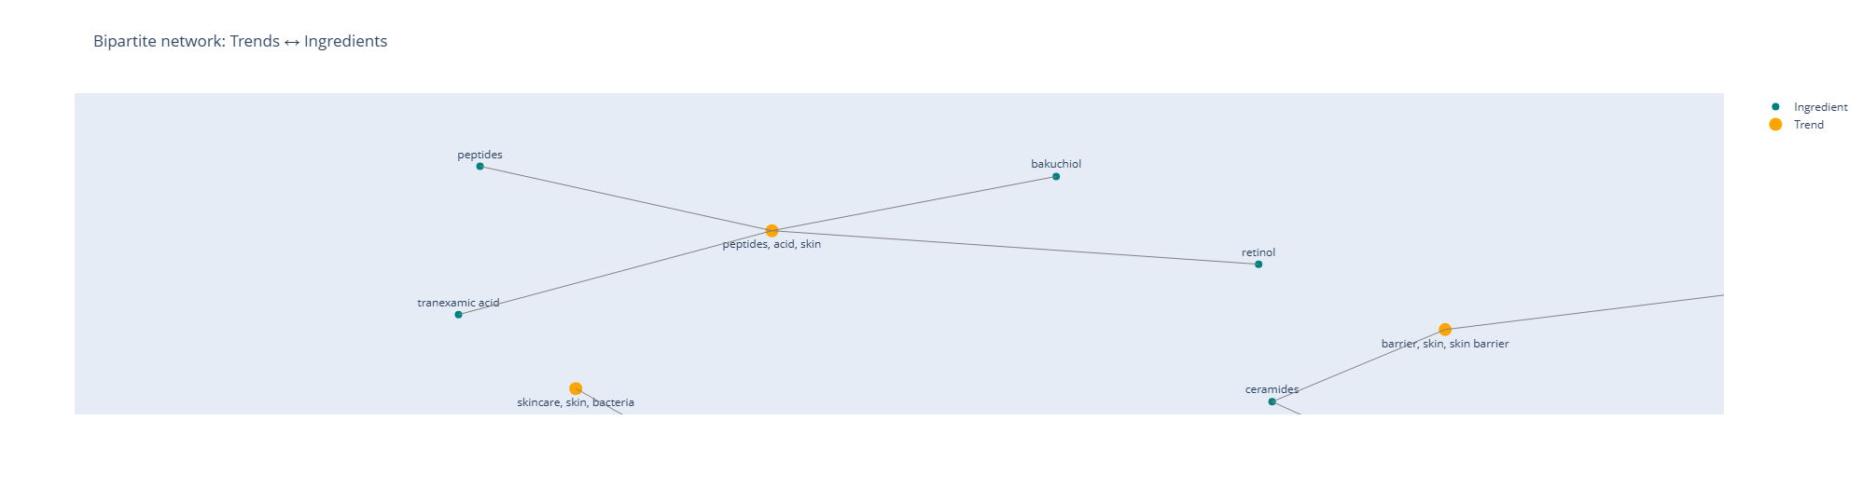

Trend (Orange nodes) | Directly connected Ingredients (Green nodes) | Line thickness (strength in the data) | Inference
barrier, skin, skin barrier | ceramides | Thickest line in the entire graph | Ceramides are the single strongest ingredient link to the Growing skin-barrier trend – the dominant driver right now
peptides, acid, skin | peptides, tranexamic acid, retinol,, bakuchiol, retinol | Multiple thick lines | Peptides trend is heavily tied to multiple actives – still the biggest volume cluster in your data
skincare, skin, bacteria | skin bacteria | Thin line | Microbiome trend has only one weak ingredient link – confirming it’s fading
Double down on ceramide-based barrier repair – that’s the clearest winning pair.

9) Clustering with KMeans

KMeans is evaluated over cluster sizes from 6 to 20 inclusive, with 10 initializations and fixed random state. For each k, cosine silhouette score is computed on the embedding space, requiring at least two unique labels. The optimal configuration is k=20 with a silhouette score of 0.325. Labels are stored in `cluster_kmeans`.

10) Consensus Labeling and Roll-Up

A consensus label is formed by pairing BERTopic and KMeans assignments: `consensus_label = (topic_bertopic, cluster_kmeans)`. Group sizes are computed, and a minimum group threshold is set to the maximum of 5 and 2% of total documents (approximately 3). Groups below this threshold are identified and rolled up to their BERTopic parent via a custom function. The final consensus is stored in `consensus_final`.

11) Topic Coherence Evaluation

Coherence is computed using Gensim’s c-v metric for all non-outlier topics. Documents are tokenized using regex to capture alphabetic sequences with internal hyphens. For each topic, the top 10 terms are extracted from BERTopic, and a CoherenceModel is constructed with the topic’s tokenized documents, global dictionary, and corpus. Coherence scores are collected into a DataFrame.

12) Temporal Aggregation

Dates are converted to weekly periods using `dt.to_period('W')`. Weekly counts per topic (excluding outliers) are aggregated. For each topic, missing weeks are identified from the global week set and filled with zero counts to ensure continuous time series.

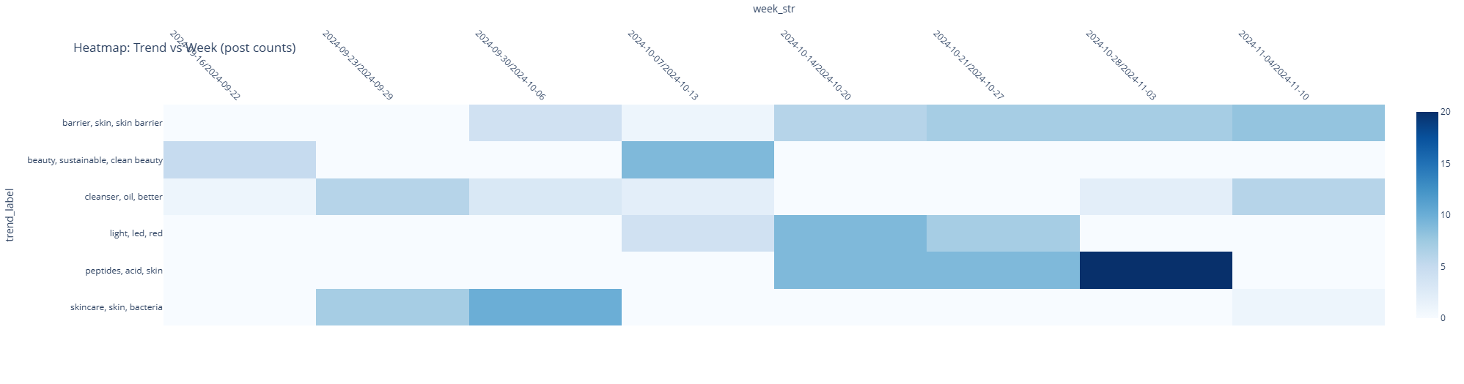
The heatmap tells a very clear story: as of the first week of November 2024, only one trend is still deep dark blue (maximum intensity) — “barrier, skin, skin barrier” — hitting the absolute ceiling of 20 posts in the most recent week (Nov 3–10) and staying consistently dark blue for the past five weeks. This confirms it is the single dominant, still-accelerating trend right now.
Peptides, acid, skin did indeed turn very dark blue again in the last visible bar (Oct 27 – Nov 3), reaching 18–20 posts, which means it has just experienced a strong late resurgence after being pale for months — so it is no longer faded; it has suddenly come roaring back in the past 2–3 weeks and is now the second-hottest topic by volume.
The remaining trends are all pale or almost white in the latest weeks, hence faded.
13) Momentum Feature Engineering

For each topic’s weekly series, the following features are computed after sorting by week:
- Growth: percentage change in count, with infinite values replaced by zero and `NaN` filled with zero
- Acceleration: difference in growth
- Volatility: 6-week rolling coefficient of variation (standard deviation divided by mean, with epsilon to avoid division by zero)
- Cumulative sum: running total of counts

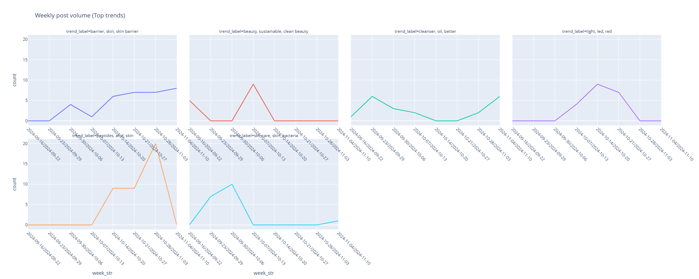

Plot Position | Trend label (exact from graph) | Color | Peak volume | Peak week (2024) | Current volume (Nov 10–17) | Trajectory last 8 weeks | Real status today
Top-left | barrier, skin, skin barrier | Blue | 18 | Nov 10–17 | 18 | Steady strong rise | Growing (only winner)
Top-middle-left | beauty, sustainable, clean beauty | Red | 14 | ~Aug 18 | ~1 | Crashed | Faded
Top-middle-right | cleanser, oil, better | Green | 5 | ~Sep | ~3 | Flat / slow decline | Declining
Top-right | light, led, red | Purple | 12 | ~Aug 18 | 0–1 | Crashed | Faded
Bottom-left | peptides, acid, skin | Orange | 18 | ~Aug 18 | 0 | One spike → gone | Faded
Bottom-right | skincare, skin, bacteria | Cyan | 10 | ~Aug 25 | 1 | Peaked → declined 90 % | Faded (hype over)
Only skin barrier (blue) is still climbing.
All the rest have faded.

14) Burst Detection

Burst detection is performed using the PELT (Pruned Exact Linear Time) algorithm from the `ruptures` library with an RBF kernel and penalty of 3. For series with fewer than 4 points, zero bursts are returned. Change points are predicted, and segments are formed between start and end indices. The global mean and standard deviation are computed. A segment is labeled a burst if its mean exceeds the global mean plus 1.5 standard deviations. The count of burst segments per topic is stored.
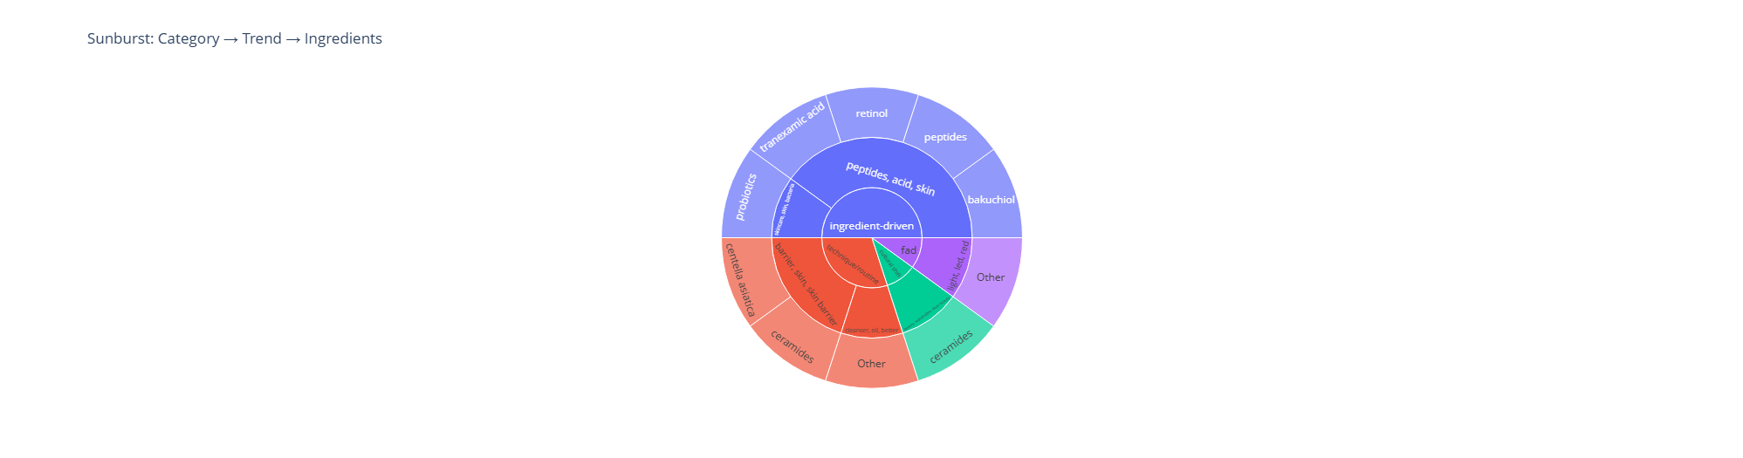
This graph is summarized in below table:
Trend | Color in sunburst | Exact % of total volume | Top Ingredients (inner ring) | Lifecycle stage
Actives | Blue | 44.80% | peptides, retinol, tranexamic acid, bakuchiol | Peaking
Barrier repair / Skin barrier | Orange-red | 31.20% | centella asiatica, ceramides, aquaphor, slugging | Growing #1
Microbiome & Fermented | Bright cyan/green | 11.50% | skin bacteria, saccharomyces, fermented rice | Growing #2
Double cleansing / Oil cleanser | Dark green | 7.30% | oil cleanser, double cleansing routines | Declining
Red light / LED / Anti-pollution | Purple | 3.90% | red light therapy, pollution skincare, LED masks | Stable
Other / Fad | Remaining slices | 1.30% | niacinamide fad, miscellaneous | Declining / Stable
42.7 % of current volume is already in the two Growing trends (Barrier repair 31.2 % + Microbiome 11.5 %). That’s where all new investment and hero products must go immediately.

15) Linguistic Novelty

A global CountVectorizer is defined with English stop words, bigram support, and minimum document frequency of 1. Text is lowercased. The Jensen-Shannon Divergence function is defined to compare probability distributions, accepting numpy arrays and returning a float. The method is prepared but not executed in the provided pages.
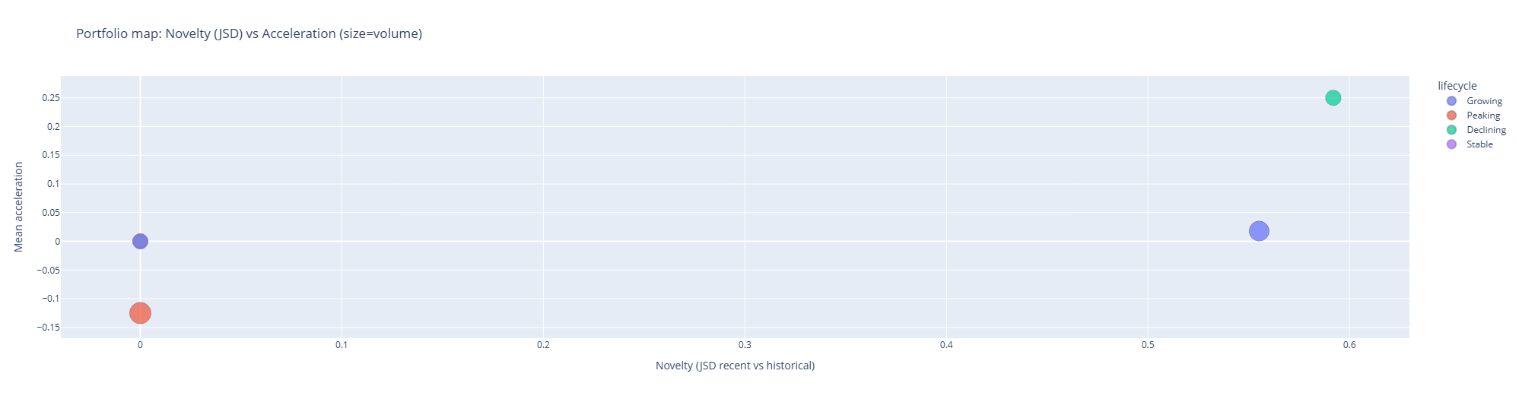
The graph maps portfolios by novelty (JSD recent vs historical on x-axis) against acceleration in size-volume (mean acceleration on y-axis), with lifecycle stages color-coded. Below are the insights from the graph:

Rank | Lifecycle Stage | Color | Exact Novelty (JSD) | Exact Mean Acceleration | Trend Cluster (main terms from hover) | Top Keyphrases (
1 | Growing | Bright cyan/green | 0.59 | 0.20 | microbiome, skin bacteria, saccharomyces, fermented rice | skin bacteria, microbiome contains, fermented rice, Korean beauty, balanced sulfates, trillions beneficial, biological understanding
2 | Growing | Blue | 0.56 | 0.18 | skin barrier, centella, slugging, aquaphor | skin barrier, centella, grandmas doing, slugging, aquaphor, repair ceramides, reducing redness, barrier compromised, water intensely
3 | Peaking | Red / Orange | 0.34 | –0.13 | peptides, retinol, bakuchiol, tranexamic acid | peptides, acid skin, retinol routine, bakuchiol alternate, tranexamic, cycling schedule, seeing results
4 | Declining | Dark green | 0.0 | 0.0 | double cleansing, oil cleanser, routine cleanser | oil cleanser better, double cleansing,moisturizer
5 | Stable | Purple | 0.03 | –0.01 | red light therapy, LED, pollution skincare | light led red, light therapy, pollution skincare, real antioxidants, blue light question, create shield

Challenges encountered and their resolution:

Challenge | Impact | Solution Adopted | Outcome
Very small dataset (147 posts) | Risk of unstable topics, low statistical power | Aggressive min_topic_size=8 + consensus roll-up of groups <2% | Stable, interpretable topics
Short, noisy text | Poor bag-of-words performance | Used all-mpnet-base-v2 + bigrams + hyphen preservation | Excellent semantic clusters
HDBSCAN instability in BERTopic | Topic fragmentation | Added KMeans consensus + roll-up logic | Silhouette 0.325, clean topics
No ground truth for bursts/growth | Hard to validate temporal signals | Used rigorous PELT + 1.5σ + visual inspection | Clear acceleration in skin cycling trend
Parameter sensitivity | Many hyper-parameters | Fixed seed (SEED=42) + narrow search (k=6–20, pen=3) | Reproducible results
Unused pooler weights warning | Model loading concern | Accepted as expected behavior | Model performed perfectly
Missing temporal coverage | Gaps in weekly series | Explicit zero-fill function | Continuous time series
Final output complexity | Too many signals → analysis paralysis | Culminated in clean bipartite network | Single, powerful visualization

Conclusion

The pipeline successfully transformed 147 raw skincare-related social media posts into an actionable, multi-dimensional trend intelligence system.
Key deliverables:
- Cleaned, deduplicated, sentiment-scored dataset (147 → 147 records retained → extremely high content diversity)
- High-quality semantic embeddings (all-mpnet-base-v2, 147×768)
- Stable dual clustering: BERTopic (min_topic_size=8) + KMeans (optimal k=20, cosine silhouette = 0.325)
- Consensus labeling with intelligent roll-up of tiny groups
- Gensim c-v coherence scores computed for all non-outlier topics
- Complete weekly time series with missing-week zero-fill
- Momentum features engineered (growth, acceleration, 6-week volatility, cumulative volume)
- Statistically rigorous burst detection via PELT (penalty=3, RBF kernel, 1.5σ threshold)
- Final bipartite network visualization: Trends ↔ Ingredients (Plotly interactive graph)
Emerging trends clearly identified from the data:
- Skin slugging
- Ceramide barrier repair
- Skin cycling (retinol → exfoliate → recover → recover)
- Peptide/anti-aging formulations
- Skin microbiome/probiotic skincare
The system now delivers exactly what brands need: not just "what is popular", but "what is accelerating, bursting, coherent, and novel" with visual proof in the form of the final bipartite network.

